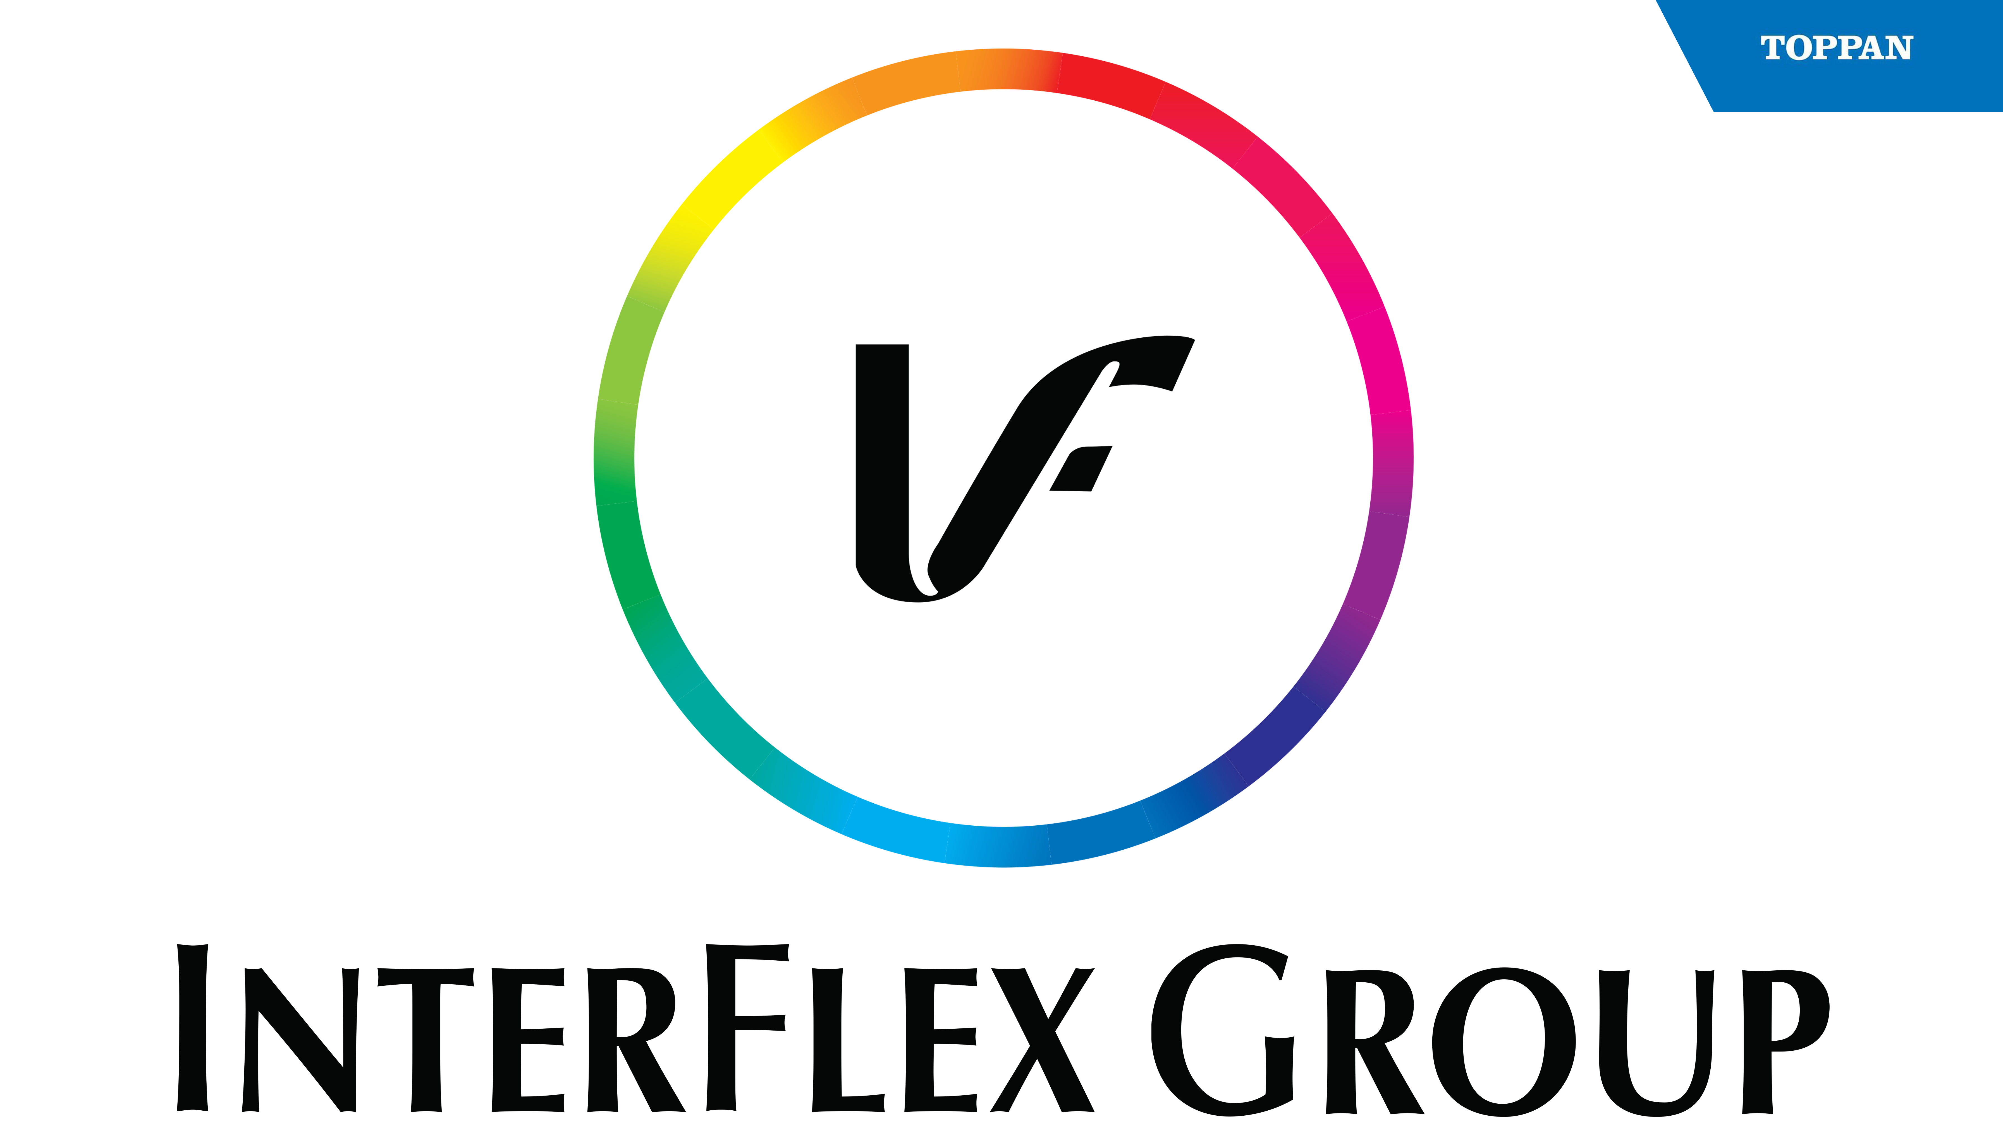

PRESS RELEASE 1 December 22

InterFlex Group (Toppan) pushes the boundaries
on recyclable paper solutions with Nestlé Quality Street
Quality Street, one of Nestlé's most popular confectionery brands in the UK and across the world, is introducing recyclable FSC-certified paper packaging for its twist-wrapped sweets worldwide.
The landmark move from dual foil and cellulose to recyclable paper wrappers will see Quality Street remove almost 2.5 billion individual pieces of packaging material from its supply chain globally.
Key to this success has been the collaborative approach between InterFlex Group (Toppan) and Nestlé's Confectionery Research and Development Centre in York, UK, as well as the Swiss-based Nestlé Institute of Packaging Sciences.
The transition to paper required extensive development in the engineering of new materials, coating technologies, printing techniques and the adaptation of existing equipment.
InterFlex Group’s continued growth and experience in recyclable paper solutions was a driving factor behind the speed and execution of this sustainability transformation.
“InterFlex Group (Toppan) has shown great resilience and tenacity whilst overcoming the many challenges that were faced when moving Quality Street twist wrapped sweets to recyclable paper,” said Michael Carroll, Expert Line Manager, NPTC Confectionery.
Paul Jenkin, UK NPD & Sustainability Lead at InterFlex, has seen a seismic shift in both the packaging industry’s pull for paper solutions, but also what is now possible to deliver into the marketplace.
“Our ability to take certain film specifications, across different end user markets, and move them to paper substrates continues to grow. We understand recyclable paper solutions might not be the panacea for all specifications, but the art of the possible continues to grow!”
InterFlex Group is proud to announce its essential environmental initiative InterFlex Protects, which helps brands and retailers navigate sustainability transformation with confidence by providing the support and solutions they need to evolve their products to hit sustainability goals.
Its new Planet-Ready Packaging range also offers brands and retailers a complete toolkit of recyclable alternatives that will help protect and future-proof their brands and products without disrupting packing line efficiencies.
To find out more about InterFlex Group, please visit www.interflexgroup.com or the new Planet-Ready packaging range at www.planetreadypackaging.com

Ends.

Notes for editors
InterFlex Group is a global flexible packaging supplier supporting recognised brands for many of the Fortune 1000 packaged goods companies in North America and Europe. The company focuses on packaging applications in the protein, pet, confectionery, snack, bakery, personal care, and industrial markets. InterFlex was founded in 1975 and is headquartered in Wilkesboro, North Carolina. The company has four facilities in the US located in North Carolina, Merrill, Wisconsin, and Appleton, Wisconsin and two in the UK, located in Sunderland and Dalkeith.

